Conference Menu
2013

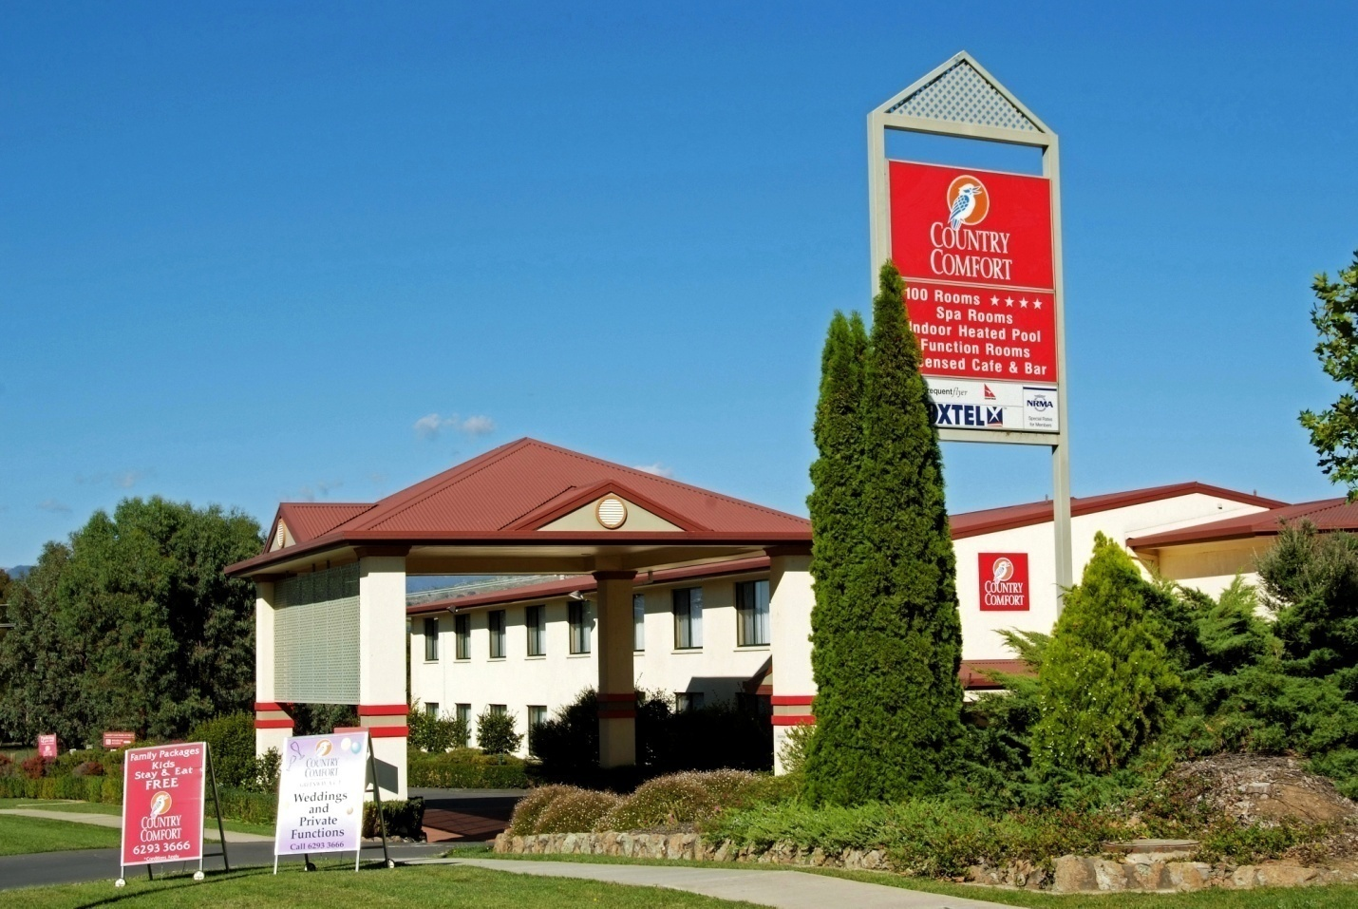

BREAKFASTS

May be served to the table or offered as a buffet

WAKE-UP BREAKFAST $24.00 per person
Fresh range of juices
Selection of French pastries - Danishes, croissants and muffins
Selection of breads including raisin bread
Selection of cereals
Full cream, light and soy milks
Plain yoghurt
Fresh sliced fruit platter
Freshly brewed coffee, selection of traditional teas and herbal infusions

FULL BUFFET BREAKFAST $29.50 per person
Fresh range of juices
Selection of French pastries - Danishes, croissants and muffins
Selection of breads including raisin bread
Selection of cereals
Full cream, light and soy milks
Fresh sliced fruit platter
Creamy scrambled eggs, hash brown potatoes, grilled mushrooms, oven-dried Roma tomatoes,
crispy bacon and sausages
Freshly brewed coffee, selection of traditional teas and herbal infusions

MORNING TEA OPTIONS

Please select one of the following packages

All morning teas are served with

freshly brewed coffee and tea

Package 1

Swiss inspired pastries baked on the premises

Fresh baked raisin scones with jam and cream

Package 2
Rich chocolate cake
Assortment of fresh baked cookies

Package 3
Mini ham and cheese croissants
Homemade sausage rolls

Additional Items
add $3.00 per person per item
Additional $3.00pp premium

Assorted homemade friands (Gluten free)
Profiteroles crème pattisierre
Strawberry fruit flan
French vanilla slice
Swiss chocolate filled croissants

Special dietary requirements can be catered for as long as adequate notice is given. This can be in the form of a separate plated meal or buffets can be altered to incorporate the requirements for the group.

AFTERNOON TEA OPTIONS

Please select one of the following packages

All afternoon teas are served with

freshly brewed coffee and tea

Package 1
Assorted gourmet and traditional sandwiches

Package 2
Assorted mini gourmet pies (including lamb, chicken & beef)
Vegetarian spring rolls with dipping sauce
Mini chicken sausage rolls

Package 3
Mini Petit fours
Mini blueberry muffins
Vanilla scones with jam and cream

Additional items
Add $3.00 per person per item
Additional $3.00pp premium

Duck and shitake mushroom pastry cup
Mini angus beef burger
Mini lamb kofta with minted yogurt
Pumpkin and fetta arancini
Mini chicken and leek Pie

Special dietary requirements can be catered for as long as adequate notice is given. This can be in the form of a separate plated meal or buffets can be altered to incorporate the requirements for the group.

CONFERENCE LUNCH OPTIONS

Please select one luncheon menu, each menu includes
all items listed plus soft drinks and fresh Juices

MAKE YOUR OWN SANDWICH BUFFET
This is a great casual luncheon which allows your delegates to make their own sandwich or have the items as a plated salad. This buffet is also very popular with vegetarians, vegans or delegates with specific dietary requirements.

Selection includes:

Variety of breads and rolls
Selection of cold meats & fillers
Selection of salads
Chefs condiments

COUNTRY STYLE LUNCH
(minimum 20 delegates)
A classic tasty menu with a modern twist
Selection includes:
Beef and beer hotpot
Home style curry chicken and rice
Cous cous, pumpkin and fetta salad
Garden salad with balsamic dressing
Chat potato, speck, spinach and garlic mayonnaise
Selection of fresh baked dinner rolls

SUPER SANDWICHES
Very popular luncheon menu which allows this to be an informal stand-up or sit down style luncheon served indoor, outdoor or while delegates continue to work in the conference room.
Selection includes:
Selection of gourmet sandwiches
Wraps and rolls
With fillings of
Chicken, ham, salami
Smoked salmon, roast beef, turkey
Curried egg, and salad fillings
All with matching condiments and seasoning

CLASSIC ROAST LUNCH
(minimum 25 delegates)
Classic roast lunch with attention to detail
Selections includes
Seasoned roast chicken
Garlic and rosemary lamb with balsamic glaze
Roast potato and pumpkin
Medley roasted vegetables
Homemade gravy and accompaniments
Selection of fresh baked dinner rolls

GRANDE LUNCH
(Minimum 25 delegates)
Additional $7.50pp premium
The grande lunch is a premium lunch option designed to impress your clients

Selection includes
*Chicken Rossini - chicken pieces wrapped in bacon with a garlic
white wine, thyme and cream sauce.
*Whole roasted fillet of beef marinated with hoi sin
and asian influences.
*Bowls of char grilled and roasted vegetables.
*Roasted baby chat potato.
*Homemade gravy and condiments.
*Cous cous pumpkin and fetta salad.
*Garden salad with balsamic dressing.
*Chat potato, speck with spinach and garlic mayonnaise.
*Selection of fresh baked dinner rolls.

OPTIONAL EXTRAS

Fruit Platter
Add a fresh seasonal fruit platter to any of your meal breaks
$3.50 pp

Cheese Platter
Add a cheese platter with double brie, vintage cheddar and blue vein with a variety of crackers and fresh breads and dried fruits
$4.50 pp

