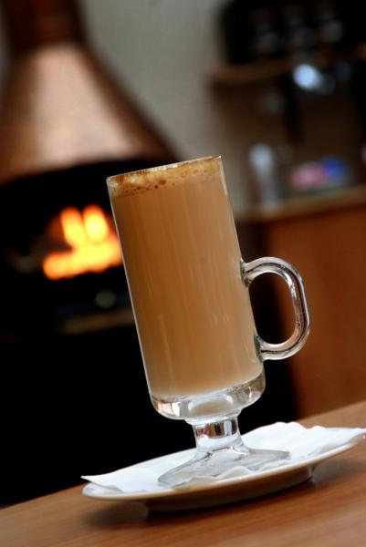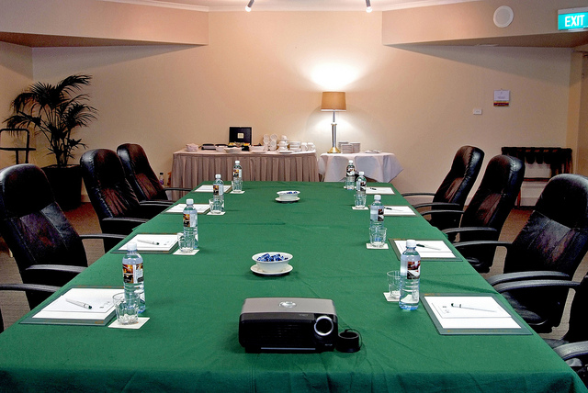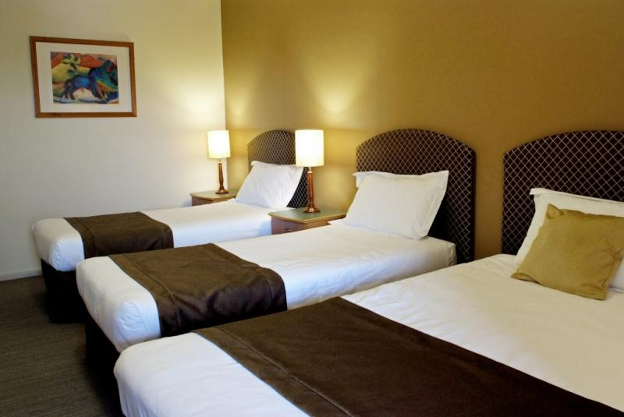

**Conference Package A-**

**$65 per delegate per day**

|  |  |
| --- | --- |
|  |  |

**Conference Room -** our “Monaro A or B” function room is ideally suited to your needs for your conference.

###### Catering Package includes:

###### Room Hire

###### Equipment Hire- blotters, pens, pads, projector screen, whiteboard, flipchart (including paper and markers), T.V and DVD/VCR, lectern.

###### Tea, coffee, iced water, mints- continuous throughout the day

###### Morning tea

###### Lunch- Hot buffet selection

###### Afternoon tea

###### Wifi

###### Parking - included

Data projector available for $150 per day

A small sound system including microphones is available for $150 per day

**Conference Package B-**

**$55 per delegate per day**

|  |  |
| --- | --- |
|  |  |

**Conference Room -** our “Monaro A or B ” function room is ideally suited to your needs for your conference.

###### Catering Package includes:

###### Room Hire

###### Equipment Hire- blotters, pens, pads, projector screen, whiteboard, flipchart (including paper and markers), T.V and DVD/VCR, lectern.

###### Arrival Tea and Coffee

###### Iced water, mints- continuous throughout the day

###### Morning tea

###### Lunch- Super Sandwich selection

###### Afternoon tea

###### Wifi

###### Parking - included

Data projector available for $150 per day

A small sound system including microphones is available for $150 per day

**Conference Package C-**

**$42 per delegate per day**

|  |  |
| --- | --- |
|  |  |

**Conference Room -** our “Monaro A or B” function room is ideally suited to your needs for your conference.

###### Catering Package includes:

###### Room Hire

###### Equipment Hire- blotters, pens, pads, projector screen, whiteboard, flipchart (including paper and markers), T.V and DVD/VCR, lectern.

###### Iced water, mints- continuous throughout the day

###### Lunch- Super Sandwich selection

###### Wifi

Data projector available for $150 per day

A small sound system including microphones is available for $150 per day

A dedicated Conference Host will service your needs for the duration of the conference

At the Country Comfort we aim to provide a **superior conference experience**.

* **Only 20 minutes from Civic, but with the peace and quiet of the country**
* **Famous Country Comfort hospitality**
* **Conference rooms with natural light and large sliding glass doors**
* **Conference rooms open onto a terrace, with views to the Brindabella Mountains**
* **Summer courtyards or winter fireplace to enjoy your breaks**
* **On site parking**

Our conference package is based on a minimum of 25 delegates. That is, should your numbers fall below 25 delegates the charge will remain at 25 delegates.

We look forward to the opportunity of making your event a success. Please advise if you are interested in making a tentative or secure booking.

**Please note, no function space has been confirmed at this stage.**

**Please do contact us as soon as possible to place your booking.**

**TO CONFIRM YOUR BOOKING**

If you would like to confirm your booking, a booking agreement will be sent for your signature. We do ask that you read our Cancellation Policy.

Once the booking has been confirmed we will send out a run of events sheet to finalise all your catering and equipment needs along with the timing of your function.

Final numbers must be confirmed 1 week prior to the event. These numbers will be used for charging purposes.

I trust the above information meets your requirements and we look forward to working with you to achieve your conference goals.

Yours Faithfully,

**Bruce Holliday**

**Function Sales Manager**