Winter 2013
Making Your Event Memorable | Country Comfort Greenway

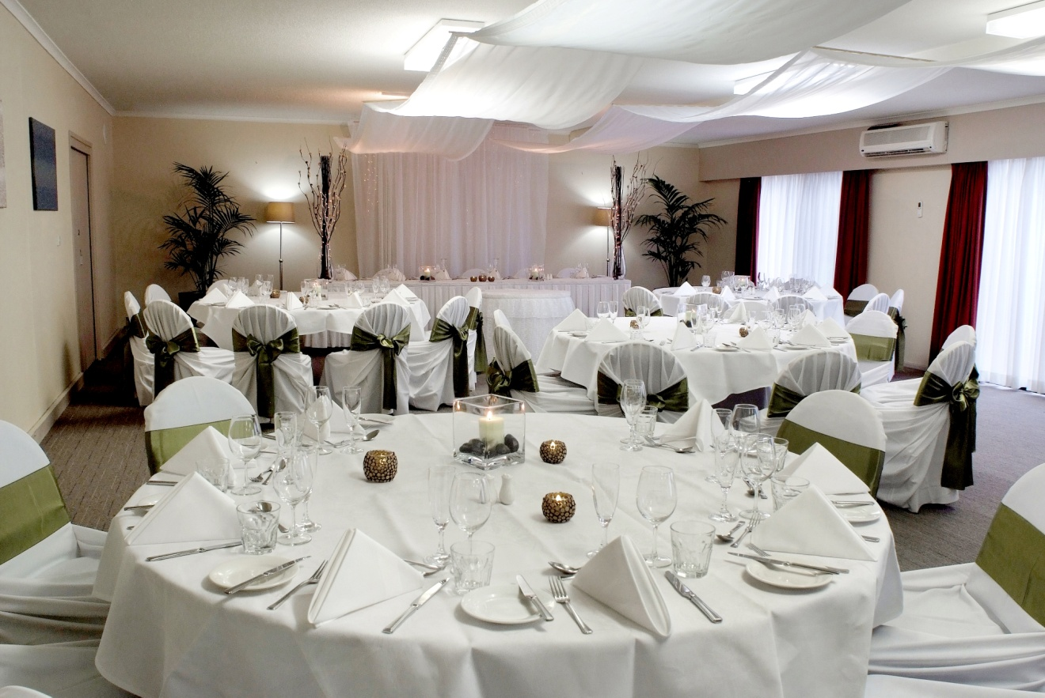
Country Comfort Greenway
46 Rowland Rees Crescent, Greenway, ACT, 2900
Phone: (02)62933666
Facsimile: (02) 62933444
Email: sales.tuggeranonghotel@gmail.com Internet: www.countrycomfortgreenway.com

Country Comfort Greenway | Function Lunches and Dinners

OPTION 1 - BUFFET

Buffet Choice 1

Buffet $39 per person
Antipasto platter for each table
(Including dips, cheeses, salami, olives, semi dried tomato, feta and more)
***
Selection of fresh breads
Cold meat platters (Chicken, ham, beef, turkey)
Garden salad
Roast potato, spinach & bacon with light garlic mayonnaise
Sweet potato, rocket, sour cream and semi-dried tomatoes
Condiments, dressings and sauces
***
Assorted dessert platter
Freshly brewed coffee and tea

Buffet Choice 2

$42.00 per person
Selection of fresh breads
***
Roasted pork or lamb
Home style roasted chicken
Roasted pumpkin and potato
Medley roast vegetables
Chef’s selection of salads, condiments and gravies
***
Assorted dessert platter
Freshly brewed coffee and tea

Buffet Choice 3

$48.50 per person
Chef’s selection soup served with crusty roll
***
Herbed fillet of beef with shiraz jus and creamed leek
Herb and garlic chat potatoes
Medley roast vegetables
Chef’s selection of gourmet salads and condiments
***
Assorted dessert platters of
Vanilla cheesecake
Banana cake
Hazelnut twists
Portuguese tarts
Chocolate profiteroles
Freshly brewed coffee, tea and chocolates

OPTION 2 – SET MENUS
Silver Selections

Sit Down Menu Alternate Serve
Two Courses $42
Three Courses $48
Add ½ hr of Chef Selected Canapés $ 8.90

Menu
Freshly baked bread rolls

Entrées (please select two)
Braised lamb and vegetable soup
Pumpkin soup
Rocket, chickpea and preserved lemon salad on dukkah lamb slices
Smoked chicken with fetta, green peas, mint, baby spinach and garlic confit

Mains (please select two)
Chicken breast supreme with apple box smoked cheddar with vermouth cream
Red wine braised slow cooked lamb shanks with soft root vegetables
Eye fillet steak cooked medium with grilled field mushroom and pinot noir jus
Beer battered flathead fillets with homemade tartar and lemon wedges
King pork cutlet with cider glaze and granny smith compote
Oven baked Tasmanian salmon fillet with citrus oil and creamed leek

All main meals served with
Garlic roasted chat potatoes
Medley of roasted vegetables
Garden salad with balsamic vinaigrette

Dessert (please select two)
Lemon and lime tart with double cream and cinnamon sugar
Pecan pie with butterscotch sauce and cream
Apple tart with brandy custard and ice cream
Sticky date pudding with butterscotch sauce and ice cream
Chocolate tart with little berry garden
Freshly brewed coffee and tea

Special dietary requirements can be accommodated in each menu with prior notice.

Golden Gastronomy
Sit Down Menu Alternate Serve

Two Courses $45
Three Courses $52
Add ½ hr of Chef Selected Canapés $ 8.90

Menu
Freshly baked bread rolls

Entrée (please select two)
Chicken and vegetable soup
Potato and bacon soup
Salt and pepper squid on a light green salad
Smoked salmon wrapped around a dome of warm Nadine potato salad with chervil hollandaise .Rocket, chickpea and preserved lemon salad on dukkah lamb slices
Smoked chicken with fetta, green peas, mint, baby spinach and garlic confit
Greek salad topped with grilled bacon and parmesan aioli
Duo of Sliders: 1 chilli chicken with mayonnaise, cheddar and rocket and 1 wagyu beef with provolone bush chutney

Main (please select two)
Grilled chicken breast supreme with apple box smoked cheddar
with vermouth cream white wine sauce
Eye fillet with grilled asparagus spears medium with a red wine jus
Slow cooked lamb shanks served with a rosemary gravy reduction
Grilled Tasmanian salmon fillet with a Greek salsa and rocket pesto dressing
Wagyu rump steak cooked medium with a mushroom sauce
Market fresh fish grilled and served with fresh salsa verde
Herbed risotto with toasted pine nuts, sundried tomato and spinach, green herb paste and Persian feta

All main meals served with
Garlic roasted chat potatoes
Roast medley of vegetables
Garden salad with balsamic vinaigrette

Dessert (please select two)
3 citrus tart with honeyed mascarpone with apple & grape freeze
Little mars bar cheesecake, chocolate puddle, raspberry granite, pressed cashew fondant
Pecan pie with butterscotch sauce and double cream
Chocolate tart with little berry garden
Sticky date pudding with butterscotch sauce and pistachio gelati
French apple tart with musk anglaise, shaved glabia and violet rounds
Lemon semi freddo with vanilla bean roundel
Freshly brewed coffee, tea and chocolates
Special dietary requirements can be accommodated in each menu with prior notice.

Beverage Packages

As a guideline to help you planning your event, we offer a choice of charging on
consumption or a beverage package.

Consumption Basis

This is based on a dollar amount set by you. We recommend you start at $20.00 per person. To extend your limit you will require a credit card or cash. We do not allow for accounts to be paid after the event.
Beverage Packages

Standard Package
House collection of wines: Cabernet Merlot, Sauvignon Blanc, Chardonnay and Sparkling Wine
James Boag Light, Pure Blonde and Carlton Draught
Soft drink and juices

2 hours - $ 25.00 per person
3 hours - $ 29.00 per person
4 hours - $ 33.00 per person

Premium Package
House collection of wines: Cabernet Merlot, Sauvignon Blanc, Chardonnay and Sparkling Wine
Pure Blonde, Crown Lager, Corona and James Boag Premium Lite
Soft drink and juices

2 hours - $ 29.00 per person
3 hours - $ 33.00 per person
4 hours - $ 37.00 per person

Deluxe Package
House collection of wines: Cabernet Merlot, Shiraz, Sauvignon Blanc, Chardonnay and Sparkling Wine
Pure Blonde, Crown Lager, Corona and James Boag Premium Lite
Spirits – Jim Beam, Smirnoff Vodka, Gordon’s Gin, Bundaberg Rum, Bacardi White rum and
Johnny Walker Red
Soft drink and juices

2 hours - $ 33.00 per person
3 hours - $ 37.00 per person
4 hours - $ 41.00 per person

Prices are fully inclusive of GST

Please Note: All staff have been trained in the responsible service of alcohol.

